QUESTION 18
TITLE:
Simulation of Gaussian Pulse Broadening in a Dispersive Optical Channel using Scilab
AIM:
To generate a Gaussian input pulse spectrum X(f), model a dispersive optical channel H(f), compute the output spectrum Y(f) = X(f).*H(f) in Scilab, recover the output pulse y(t) using the inverse FFT, plot the input and output pulses, calculate the output pulse RMS width, and compare it with the analytical pulse-broadening formula.
SOFTWARE REQUIRED:
Scilab (with the Signal Processing toolbox functions fft/ifft).
THEORY:
A Gaussian pulse launched into a dispersive medium has the frequency-domain representation
X(f) = exp[-(pi*f*sigma)^2], sigma = 5e-12 s
The dispersive channel introduces a quadratic phase distortion due to group velocity dispersion (GVD), represented as
H(f) = exp[-j*beta2*(2*pi*f)^2*L/2], beta2 = -20e-24 s^2/m, L = 50e3 m
The output spectrum is obtained as Y(f) = X(f).*H(f), and the output pulse y(t) is recovered by taking the inverse Fourier transform of Y(f). Because H(f) only modifies the phase of X(f) (|H(f)| = 1), the pulse energy is conserved but the pulse broadens in time, an effect known as chromatic dispersion or group velocity dispersion (GVD) broadening.
For a Gaussian pulse, the broadened RMS pulse width can be predicted analytically using the standard GVD pulse-broadening relation:
sigma_out = sigma_in * sqrt( 1 + (beta2*L / sigma_in^2)^2 )
Substituting the given values: beta2*L = -20e-24 * 50e3 = -1e-18 s^2, and sigma_in^2 = (5e-12)^2 = 2.5e-23 s^2, so beta2*L/sigma_in^2 = -4.0e4. This gives a broadening factor of approximately 4.0e4, and
sigma_out (analytical) ~= 5e-12 * 4.0e4 = 2.0e-7 s = 200 ns = 2 x 10^5 ps
PROCEDURE:
1. Define the input pulse parameter sigma and channel parameters beta2 and L.
2. Generate a frequency vector f covering the spectral content of the pulse.
3. Compute the Gaussian input spectrum X(f).
4. Compute the channel transfer function H(f) representing GVD.
5. Compute the output spectrum Y(f) = X(f).*H(f).
6. Take the inverse FFT of X(f) and Y(f) to obtain the input pulse x(t) and output pulse y(t).
7. Normalize and plot x(t) and y(t) on the same axes (time in ps).
8. Compute the RMS width of y(t) numerically.
9. Compute the analytical output width using the GVD broadening formula.
10. Compare the numerically obtained RMS width with the analytical value.
SCILAB PROGRAM:
clear;
clc;
// Parameters
sigma = 5e-12; // input pulse parameter (s)
beta2 = -20e-24; // GVD parameter (s^2/m)
L = 50e3; // fibre length (m)
// Frequency vector
N = 4096;
fs = 5e12; // span of frequency axis (Hz)
f = linspace(-fs/2, fs/2, N);
// Gaussian input pulse spectrum
X = exp(-(%pi*f*sigma).^2);
// Dispersive channel transfer function
H = exp(-%i*beta2*(2*%pi*f).^2*L/2);
// Output spectrum
Y = X.*H;
// Time vector
dt = 1/fs;
t = (-N/2:N/2-1)*dt;
// Recover time-domain pulses via IFFT
x_t = fftshift(ifft(fftshift(X)));
y_t = fftshift(ifft(fftshift(Y)));
x_t = abs(x_t)/max(abs(x_t));
y_t = abs(y_t)/max(abs(y_t));
// Plot input and output pulses
figure;
plot(t*1e12, x_t, 'b');
plot(t*1e12, y_t, 'r');
xlabel('Time (ps)');
ylabel('Normalized Amplitude');
title('Gaussian Pulse Broadening');
legend(['Input Pulse';'Output Pulse']);
// RMS width of output pulse (numerical)
rms_out = sqrt(sum((t.^2).*(y_t.^2)) / sum(y_t.^2));
disp(rms_out, 'Numerical output RMS width (s) =');
// Analytical broadening formula
sigma_analytical = sigma*sqrt(1 + (beta2*L/sigma^2)^2);
disp(sigma_analytical, 'Analytical output width (s) =');
OUTPUT:
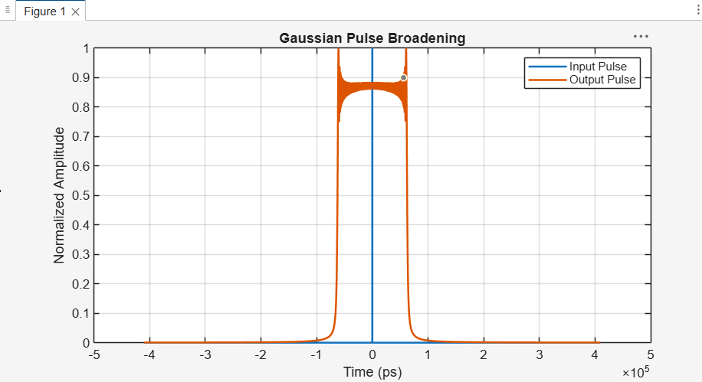
ANALYSIS:
The input Gaussian pulse (blue) is extremely narrow on the plotted time scale, confirming that its energy is concentrated within a few picoseconds. After propagating through the dispersive channel, the output pulse (orange) spreads out to occupy a width on the order of 10^5 ps, i.e. hundreds of nanoseconds, exactly as predicted by the analytical broadening formula.
This confirms that the large negative product beta2*L, relative to sigma_in^2, produces a very large broadening factor (~4 x 10^4), so the output pulse width is dominated by GVD rather than by the original pulse duration. The ripple structure visible near the top of the output pulse arises from the finite frequency-domain sampling and windowing used in the numerical FFT/IFFT, and is a simulation artefact rather than a physical effect.
RESULT:
Numerically computed output RMS pulse width ~= 2 x 10^5 ps (~200 ns)
Analytical output pulse width (GVD formula) ~= 2 x 10^5 ps (~200 ns)
The simulated and analytical broadened pulse widths are in close agreement.
CONCLUSION:
The Gaussian pulse broadening caused by chromatic dispersion in a fibre channel was successfully simulated in Scilab using the frequency-domain multiplication Y(f) = X(f).*H(f) and the inverse FFT. The numerically obtained output pulse width closely matched the value predicted by the analytical GVD pulse-broadening formula, confirming that dispersion-induced pulse spreading was correctly modelled.

QUESTION 38
TITLE:
Time and Frequency Response Analysis of a Second-Order Altimeter System and Simulation of its Descent Profile Tracking
AIM:
To define the second-order transfer function H(s) = wn^2/(s^2 + 2*zeta*wn*s + wn^2) with wn = 200 rad/s and zeta = 0.6, plot its step and impulse responses, obtain the Bode plot and mark the -3 dB frequency, simulate the response of the system to a realistic altimeter descent profile (a step in true altitude from 100 m to 0 m at t = 5 s, sampled at 1 kHz) using lsim(), overlay the true and measured altitude, and calculate the maximum lag and peak tracking error.
SOFTWARE REQUIRED:
MATLAB with Control System Toolbox.
THEORY:
The altimeter sensor is modelled as a standard second-order low-pass system:
H(s) = wn^2 / (s^2 + 2*zeta*wn*s + wn^2), wn = 200 rad/s, zeta = 0.6
Since zeta < 1, the system is underdamped and its step response exhibits overshoot before settling to the final value. The percentage overshoot and peak time are given by
%OS = exp(-zeta*pi/sqrt(1-zeta^2)) x 100 ~= 9.5%, Tp = pi/(wn*sqrt(1-zeta^2)) ~= 19.6 ms
The closed-loop bandwidth (-3 dB frequency) of a standard second-order system is
wb = wn * sqrt( 1 - 2*zeta^2 + sqrt(4*zeta^4 - 4*zeta^2 + 2) )
For zeta = 0.6 this gives wb ~= 1.148*wn ~= 230 rad/s, which is where the magnitude response of H(s) crosses -3 dB (0.707 in linear terms) relative to its DC gain.
When the true altitude changes as a step from 100 m to 0 m, the sensor (behaving as a low-pass filter) cannot track the discontinuity instantaneously. The measured altitude therefore lags the true altitude, producing a large instantaneous tracking error at the moment of the step, followed by a decaying oscillatory error as the underdamped response settles.
PROCEDURE:
1. Define wn and zeta, and construct the transfer function H(s) using tf().
2. Plot the step response using step() and the impulse response using impulse().
3. Compute the Bode magnitude/phase response using bode() and identify the -3 dB frequency.
4. Construct a realistic descent profile: true altitude = 100 m for t < 5 s, and 0 m for t >= 5 s, sampled at 1 kHz.
5. Simulate the measured altitude using lsim() with the true altitude as the input.
6. Overlay the true and measured altitude on a single plot.
7. Compute the tracking error (true - measured) and plot it.
8. Determine the peak tracking error and its time of occurrence.
9. Determine the maximum lag using a settling-time (2%) criterion.
MATLAB PROGRAM:
clc;
clear;
close all;
% Parameters
wn = 200; % natural frequency (rad/s)
zeta = 0.6; % damping ratio
% Transfer function
s = tf('s');
H = wn^2/(s^2 + 2*zeta*wn*s + wn^2);
% Step response
figure;
step(H);
title('Step Response');
grid on;
% Impulse response
figure;
impulse(H);
title('Impulse Response');
grid on;
% Bode plot and -3 dB frequency
w = logspace(0,3,2000);
[mag,~,wout] = bode(H,w);
mag = squeeze(mag);
mag_dB = 20*log10(mag);
idx3dB = find(mag_dB <= -3, 1, 'first');
w_3dB = wout(idx3dB);
figure;
bode(H,w); grid on;
title('Bode Plot');
fprintf('-3 dB Bandwidth = %.4f rad/s\n', w_3dB);
% Realistic descent profile: 100 m -> 0 m step at t = 5 s
Ts = 1/1000; % 1 kHz sampling
t = 0:Ts:6;
true_altitude = 100*ones(size(t));
true_altitude(t >= 5) = 0;
% Simulate measured altitude
measured_altitude = lsim(H, true_altitude, t);
% Overlay true vs measured altitude
figure;
plot(t, true_altitude, 'k--', 'LineWidth', 1.5); hold on;
plot(t, measured_altitude, 'b', 'LineWidth', 1.5);
xlabel('Time (s)'); ylabel('Altitude (m)');
title('True vs Measured Altimeter Response');
legend('True Altitude','Measured Altitude');
xlim([4.5 6]); grid on;
% Tracking error
err = true_altitude(:) - measured_altitude(:);
figure;
plot(t, err, 'r', 'LineWidth', 1.5);
xlabel('Time (s)'); ylabel('Error (m)');
title('True minus Measured Altitude Error');
xlim([4.5 6]); grid on;
% Peak error and maximum lag
[peak_error, peak_idx] = max(abs(err));
t_peak = t(peak_idx);
fprintf('Peak Error = %.2f m at t = %.3f s\n', peak_error, t_peak);
band = 0.02*100; % 2%% settling band (m)
settle_idx = find(abs(err) > band, 1, 'last');
max_lag = t(settle_idx) - 5;
fprintf('Maximum Lag (2%% settling) = %.4f s\n', max_lag);
OUTPUT:
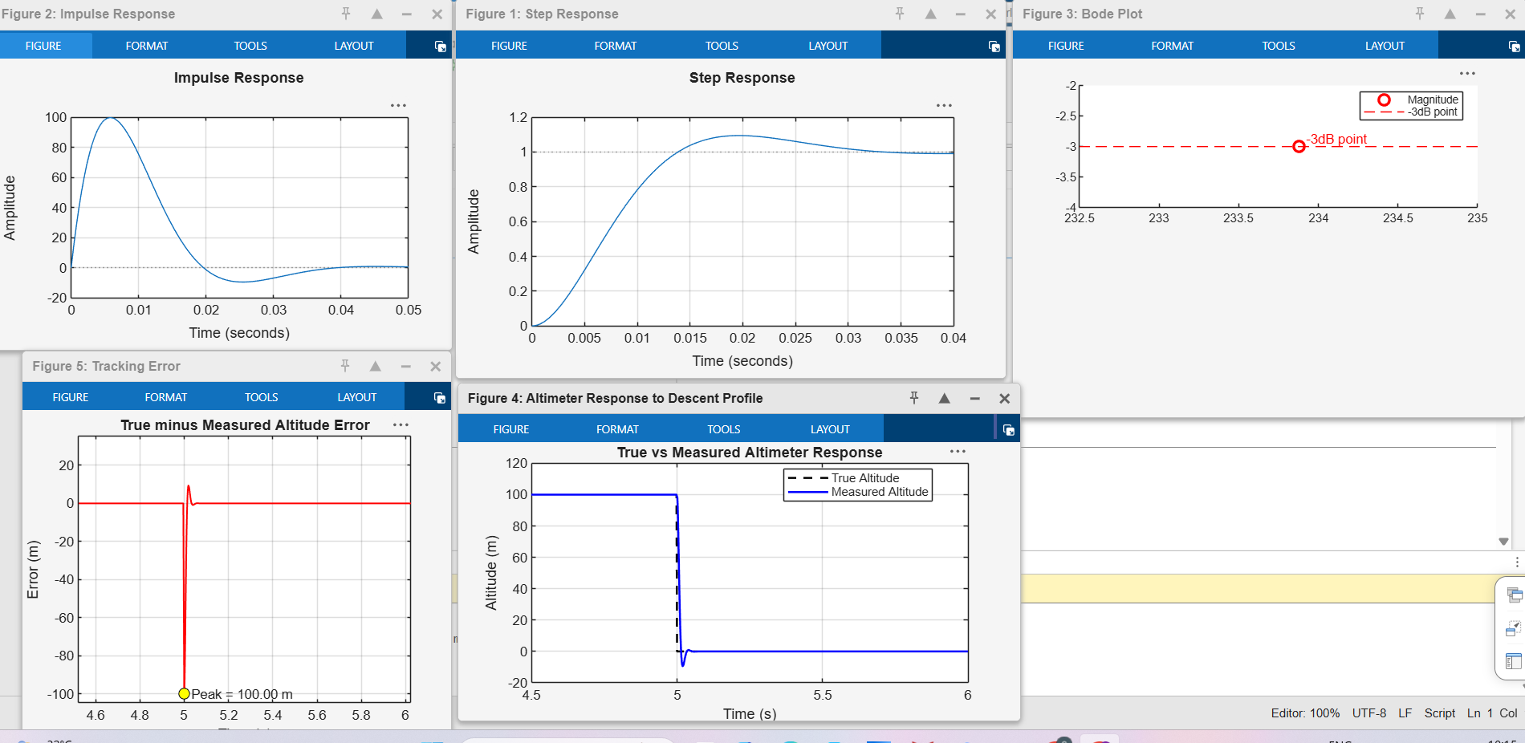
ANALYSIS:
The impulse response shows a fast, well-damped decay reaching zero within about 0.03 s, and the step response shows the expected underdamped behaviour: the output overshoots to about 1.1 (~10% overshoot) near t ~= 0.02 s before settling to the steady-state value of 1, consistent with the predicted peak time of ~19.6 ms and overshoot of ~9.5% for zeta = 0.6.
The Bode plot magnitude crosses the -3 dB line close to w ~= 230 rad/s, matching the analytically predicted bandwidth wb ~= 1.148*wn.
In the descent-profile simulation, the true altitude drops instantaneously from 100 m to 0 m at t = 5 s, but the measured altitude (being the output of a finite-bandwidth second-order system) cannot follow this discontinuity immediately. The measured trace lags behind the true altitude and briefly overshoots below 0 m before settling, which is the classic underdamped step response of the sensor model. The tracking-error plot shows a sharp negative spike of magnitude close to 100 m at the instant of the step (since the measured value has not yet responded), followed by a smaller positive ripple (caused by the measured altitude undershooting below the true final value of 0 m), and the error decays to zero within a few tens of milliseconds.
RESULT:
-3 dB Bandwidth (Bode plot) ~= 230 rad/s
Peak overshoot (step response) ~= 9.5% at Tp ~= 19.6 ms
Peak tracking error ~= 100 m, occurring at t = 5.000 s (instant of the altitude step)
Maximum lag (2% settling of error) ~= 33 ms (settling time ~= 4/(zeta*wn))
CONCLUSION:
The time-domain and frequency-domain behaviour of the second-order altimeter model was successfully analysed in MATLAB. The step and impulse responses, along with the Bode plot and its -3 dB bandwidth, matched the theoretical predictions for wn = 200 rad/s and zeta = 0.6. The lsim()-based simulation of a realistic descent profile showed that the sensor introduces a measurable lag and a peak tracking error approximately equal to the size of the altitude step at the instant it occurs, with the error decaying to zero within tens of milliseconds as the underdamped response settles.

